Nestle Toll House Chocolate Chip Cookie Recipe

Ingredients

2 1/4 cups all-purpose flour

1 teaspoon leavening agent (Group 1: baking soda, Group 2: baking powder, Group 3: 1/3 cup extra flour, Group 4: none)

[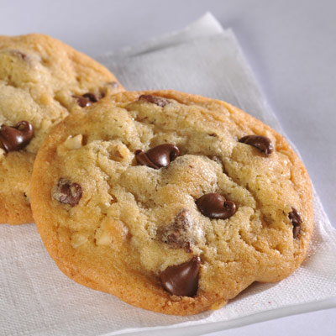](https://www.google.com/url?sa=i&rct=j&q=&esrc=s&frm=1&source=images&cd=&cad=rja&uact=8&ved=0CAcQjRw&url=https://www.verybestbaking.com/recipes/18476/original-nestle-toll-house-chocolate-chip-cookies/&ei=NmfKVOnPJYquyQTNmoHgBw&bvm=bv.84607526,d.aWw&psig=AFQjCNHPh4RdOBi8iDbSUwkEQlVq8TEXsA&ust=1422637235800882)1 teaspoon salt

1 cup (2 sticks, 1/2 pound) butter, softened

3/4 cup granulated [white] sugar

3/4 cup packed brown sugar

1 teaspoon vanilla extract

2 eggs

2 cups (12-ounce package) NESTLE TOLL HOUSE Semi-Sweet Chocolate Morsels

1 cup chopped nuts (optional)

Directions:

1. COMBINE flour, leavening agent (if any) and salt in small bowl.
2. Meanwhile, beat butter, granulated sugar, brown sugar and vanilla in large mixing bowl or stand mixer.
3. Add eggs one at a time, beating well after each addition; gradually beat in flour mixture. Stir in chocolate chips and nuts.
4. Drop by rounded tablespoon onto ungreased baking sheets.
5. BAKE in preheated 375-degree [Fahrenheit] oven for 9 to 11 minutes or until golden brown. Let stand for 2 minutes; remove to wire racks to cool completely. Once cookies bake and cool, place them in an air tight container for Day 2.

PAN COOKIE VARIATION: PREPARE dough as above. Spread into greased 15"x10" jelly-roll pan. Bake in preheated 375-degree [Fahrenheit] oven for 20 to 25 minutes or until golden

Leavening Agent Questions (Day 2)

1. Compare each cookie based on appearance, taste, and texture.

|  |  |  |  |
| --- | --- | --- | --- |
| Cookie | Appearance | Taste | Texture |
| 1: Baking Soda |  |  |  |
| 2. Baking Powder |  |  |  |
| 3. Too much flour |  |  |  |
| 4. No leavening agent |  |  |  |

1. What was your favorite cookie overall (appealing to your eyes, taste buds and texture)?
2. What was your least favorite cookie overall (least appealing to your eyes, taste buds and texture)?
3. Why are leavening agents important in baking?
4. What is the overall difference in turn out between the cookie using baking soda vs. baking powder?