**Starbucks Copycat Lemon Loaf**

Ingredients

* [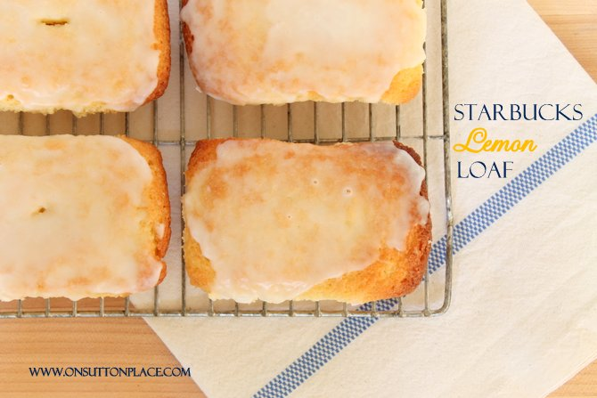](http://www.onsuttonplace.com/wp-content/uploads/2013/01/IMG_61262.jpg)1 1/2 c. flour
* 1/2 t. baking powder
* 1/2 t. baking soda
* 1/2 t. salt
* 3 eggs at room temp.
* 1 c. sugar
* 2 T. butter softened
* 1 t. vanilla
* 2 t. lemon extract
* 1/3 c. fresh lemon juice
* 1/2 c. oil
* zest of one lemon

Glaze

* 1 c. powdered sugar
* 2 T. milk
* 1/2 t. lemon extract
* juice of 1/4 lemon

Instructions- Day 1

* 1. Preheat oven to 350. Grease 9 x 5 loaf pan or 6 mini pans.
* 2. In a large bowl combine flour, baking soda, baking powder and salt. Form a well and set aside.
* 3. In a medium bowl of KitchenAid mixer, combine eggs, sugar, butter, vanilla and lemon extracts, and lemon juice with a mixer on medium speed. Scrape bottom to make sure all is combined.
* 5. Gradually pour wet ingredients into dry ingredients and blend until smooth, scraping sides and bottom of bowl. You can use a whisk or wooden spoon.
* 6. Add oil and lemon zest. Mix well, but be careful not to over mix.
* 7. Pour into prepared loaf pan(s) and bake for 45 min. (9 x 5) loaf pan or 25 min. (minis.) Insert toothpick to test...it must come out clean. Remove from oven and let sit 3 minutes. Remove bread from pan(s) onto wire rack.
* 8. Prepare glaze by whisking all ingredients together. Cover and refrigerate for Day 2.

Day 2

* Pour glaze over bread. Slice and enjoy.

Pan measurements

* mini = 2 1/2 in. x 4 in. = 25 minutes
* small = 3 in. x 5 1/2 in. = 30 minutes-35 minutes
* large = 9 in. x 5 in. = 45 minutes