**Homemade Granola Bars**

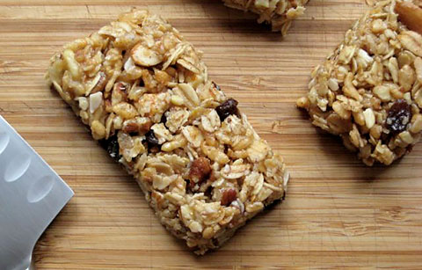Nonstick cooking spray  
1 c. old-fashioned oats  
¼ c. honey or agave nectar  
¼ c. vegetable oil  
1 tbsp. water  
1 large egg white  
1 tbsp. packed light brown sugar  
1/2 tsp. ground cinnamon  
¼ tsp. salt

6 Tbsp. wheat germ  
½ c. mini chocolate chips

¼ c. raisins or cranberries

Directions  
  
1. Preheat oven to 325 degrees F. Spray 8 x 8-inch metal baking pan with nonstick cooking spray.

2. Line pan with foil, leaving 2-inch overhang; spray foil. Spread 2 cups old-fashioned oats on plate; microwave on high, in 1-minute intervals, 4 to 5 minutes or until fragrant and golden, stirring occasionally. Let cool.

3. In large bowl, whisk honey or agave, vegetable oil, water, egg whites, light brown sugar, ground cinnamon, and salt until well blended. Fold in oats and toasted wheat germ, chocolate chips, and dried cranberries; transfer to prepared pan.

4. Using wet hands, press into even layer.

5. Bake 28 to 30 minutes or until golden. Cool in pan on wire rack. Using foil, transfer to cutting board; cut into 8 bars.