**[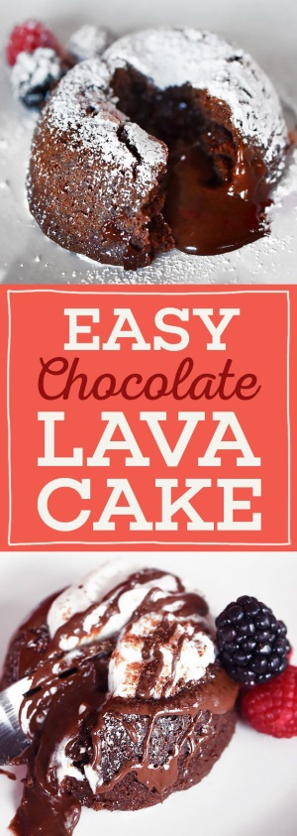](http://www.buzzfeed.com/christinebyrne/i-lava-you?crlt.pid=camp.5NzCfLzEh6lu#.skvmBdYw9)Chocolate Lava Cakes**

Serves 6

**INGREDIENTS**  
12 ounces semisweet baking chocolate, chopped  
6 tablespoons unsalted butter, at room temperature, plus more for greasing custard cups  
6 tablespoons sugar, plus more for the custard cups  
6 large eggs  
6 tablespoons all-purpose flour  
1/2 teaspoon kosher salt

**PREPARATION**  
1. Preheat oven to 425°F, and grease six glass custard cups or ramekins generously with butter. Put a small spoonful of sugar in each cup, then turn the cup sideways and rotate it so that the sugar is coating the butter all around. Dump out any excess sugar. Place the greased cups on a baking sheet.

2. Put the chopped chocolate in a microwave-safe bowl. Microwave it on high for 30 seconds, take it out and stir it, then microwave it for another 30 seconds and stir it again. It should be completely melted. If there are still chunks of unmelted chocolate, microwave for another 20 seconds and stir.

3. In a medium mixing bowl, cream the room temperature butter and the sugar with an electric mixer. The mixture should be thoroughly combined, smooth, and paste-like, not lumpy.

4. Add the eggs (2 at a time) to the creamed butter and sugar, and beat it with the electric mixer or a whisk until everything is combined and the mixture is starting to foam, about a minute or two. Add the flour and salt, and again beat everything with the mixer until it’s thoroughly mixed.

5. Add about 1/3 of the melted chocolate to the mixture in the mixing bowl, then use a rubber spatula to gently fold it in. Add the rest of the chocolate mixture, and fold together until you have a uniform batter with no streaks.

6. Divide the batter evenly between the six greased custard cups, then bake the cakes in the preheated oven until the tops are just set but the cakes still jiggle slightly when you shake them, about 11 minutes.

7. Let the finished cakes sit in cups for five minutes when they’re finished baking. Then, flip each cup over on a dessert plate, and tap the bottoms of the cups so that the cakes fall out.

8. Serve immediately. If you want, you can garnish them with powdered sugar, whipped cream, and berries.