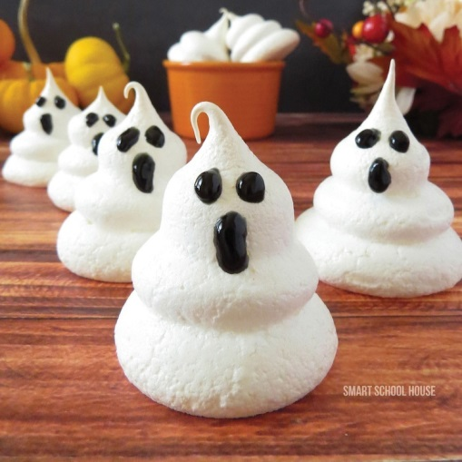**Ghost Meringues**

Ingredients

* 4 Egg Whites
* 1/2 tsp. Cream of Tartar
* 1 cup of Sugar
* Black Decorating Icing Gel

Instructions

1. Preheat oven to 225 degrees.
2. Using an electric mixer, whip the egg whites for a few minutes on high speed until they become frothy (you will see lots of little bubbles).
3. Next, add your sugar in small amounts at a time.
4. Finally, mix in the cream of tartar.
5. Continue to whip the mixture until it gets stiff (meaning that it holds a shape when stopped).
6. Prepare your baking sheet with a layer of foil covered with non-stick spray.
7. Place the meringue mixture into an icing bag.
8. Using your icing bag and a large round icing tip, continually press the meringue mixture directly down onto the foil. Press down and lift up to create layered stacks for each ghost (release the pressure just a tiny bit, pulling up on your frosting bag at the same time in between each layer).
9. Bake them for about 45 minutes or until the tops become a little brown.
10. Once they are completely cooled, they will harden and be ready to decorate with black gel frosting!
11. Add eyes and mouths to your ghost (or create silly faces!).
12. Store in an air tight container.

**Meringue Tips**

1. Be sure to use a metal or glass bowl. Plastic won’t work.
2. Try not to get any yolk into the egg white- the meringue won’t créate.
3. Have eggs at room temp. Before starting.
4. Toast in a turned-off oven for an additional 10-15 mins. for a nice crispy texture!

Meringue Demonstration

* Meringues require only egg whites. To get this amount you should:
  + - Crack eggs **________** at a time, and allow __________to fall into custard cup. Make sure they are at _______________. Transfer egg whites to kitchen aid mixing bowl and repeat process.
    - If you get __________in the egg whites, throw them out and start over.
* Recipes will direct you to beat egg whites to one of three stages: _________, ____________,________________.
* The meringue recipe first requires you to beat eggs to the ____________ stage. This will appear as bubbles or foam on the surface. At this point add in the flavoring agents.
* Continue beating until the _____________stage: egg whites stand up in the form of a peak, but the tip bends over.
* You must reach this stage **_________**you add the sugar!!
* Add the sugar a tablespoon at a time and continue beating until the __________stage.
* At the stiff peak stage, the egg whites are full of volume and stand up in the form of a peak. They do not bend!

Schema/Recipe SEO Data Markup by [ZipList Recipe Plugin](http://www.ziplist.com/recipe_plugin)

2.6