**Homemade Classic Apple Pie**

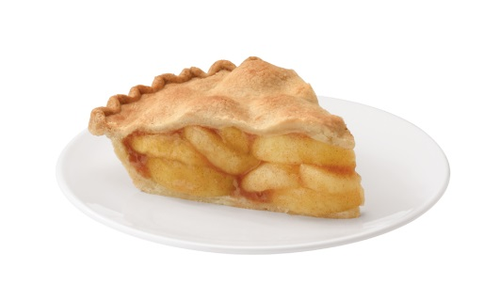**The crust (makes 2 pie crusts):**

Ingredients:

•1 cup butter, diced and chilled

•2 1/2 cups all-purpose flour

•1/2 teaspoon salt

•3-5 tablespoons ice water

Directions:

1. Combine flour and salt in food processor. Pulse once to mix. Alternately, whisk in a large bowl if you are not using a food processor.

2. Add butter and process until it resembles coarse crumbs. Add 2 tablespoons of water and pulse, a few times. I always add a third tablespoon of water and pulse until the dough forms a ball. This takes a few seconds. If you find your mixture is too dry, you can add another tablespoon of water. Turn out the dough onto a lightly floured surface.

3. Alternately, without a food processor, cut your butter in using a pastry cutter. Work in one tablespoon of butter at a time, then turn out the dough onto a floured surface.

4. I recommend using a silpat or other similar silicone surface for rolling. But you don't have to, you'll just have to use more flour. Press the dough ball into a disk and roll to about 1/4" thickness. Be sure to flip and rotate your dough as you go so it does not stick to your surface. Roll out the dough to a few inches larger than your pie plate (about 12" for a 9" pie plate).

For the apple mixture:

For pie filling:

5 apples, washed, peeled, cored, and sliced thin

1/2 tablespoon lemon juice

1/4 cup butter

1 1/2 tablespoons all-purpose flour

2 Tbsp. water

1/4 cup white sugar

1/4 cup brown sugar

1/2 teaspoon cinnamon (or apple pie spice)

1/8 teaspoon salt

For top of pie:

1 egg, lightly beaten

2 teaspoons sugar

scant 1/4 teaspoon cinnamon

Directions:

1. Preheat oven to 425 degrees. In a large bowl, sprinkle apples with lemon juice and toss to cover.
2. Melt the butter in a large saucepan. Stir in flour to form a paste. Add juice, sugars, cinnamon, and salt; mix well and bring to a boil. Reduce heat and let simmer for 3 minutes or until thickened slightly. Stir in apples, mixing well.
3. Place bottom crust in pie plate. Pour apples into crust, mounding slightly in the middle. Cut slits in top crust and place over top of pie. Tuck top crust edge under bottom crust edges and crimp decoratively.
4. Brush top of pie with egg wash. Mix remaining sugar and cinnamon and sprinkle over top of pie. Place pie on foil-covered cookie sheet to catch any drips.
5. Bake at 425 degrees for 15 minutes, then reduce heat to 350 degrees and continue to bake for about 35 to 45 more minutes, or until apples are done and pie is golden brown. Place on wire rack and let cool completely before slicing so that the syrupy juices can set.