**Chocolate Chip Cookie in a Mug!**

Servings: Makes 3 mug cookies

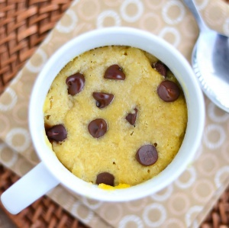Ingredients

•3 tbsp. *melted* butter

•1/2 cup + 1 tbsp. flour

•3 tbsp. granulated sugar

•3 tbsp. packed brown sugar

•1 tsp. salt

•3 tsp. vanilla extract

•3 egg yolks (separate egg before using)

•6 tbsp. chocolate chips

Directions

1. In a bowl, mix together all your ingredients except the chocolate chips, until you get sticky cookie dough batter. Stir in chocolate chips.
2. Get out 3 microwave safe mugs. ** This cookie won’t rise much, so you probably don’t want your mug/cup to be too big. **
3. Fill each of the 3 mugs equally with batter.
4. Place each mug in the microwave one at a time and cook on high for 1 to 1-1/2 minutes.

** I suggest doing this in 30 second intervals so you can check on the cookie. If it still looks kind of wet/doughy on top, leave it in the microwave for a little longer. **

1. Allow mug and cookie to cool for 30 seconds, then dig in!