**Garden Fresh Bruschetta**

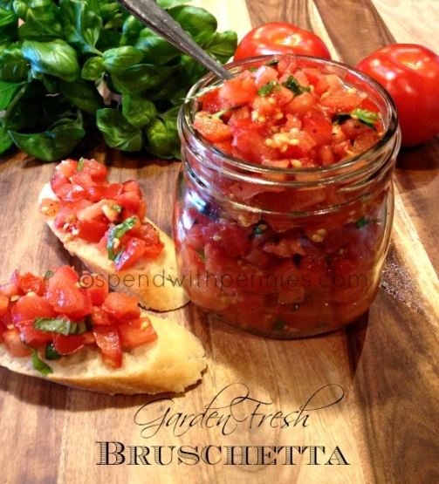

Ingredients:

* fresh tomatoes (4-5 Roma tomatoes or 3-4 regular tomatoes) diced small
* 1 clove garlic minced
* 1/4 cup fresh basil chopped fine (chiffonade)
* 2 Tbsp. Olive oil
* 1 Tbsp. red wine vinegar
* 1/2 tsp each salt & pepper (or to taste)
* 1 baguette sliced
* Olive oil

Instructions:

1. Preheat oven to 375 degrees.
2. Mix all ingredients besides baguette and let stand at room temperature.
3. Meanwhile, slice the baguette, brush with olive oil and place on a cookie sheet- lightly toast in the oven for about 5-7 minutes.
4. When done, remove baguettes from the oven and top with Bruschetta.