S.T.E.M. Enrichment Activity – **8th**

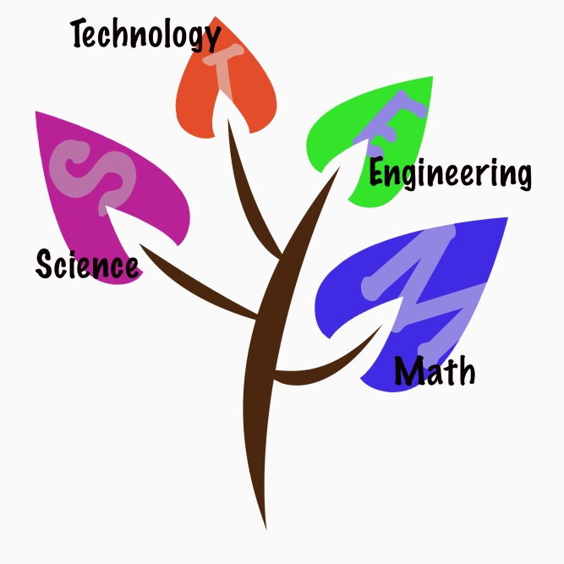

WHEN: Quarters 1 and 2

WHAT: **Task**: You are to develop an in-depth, inquiry-based visual presentation about a topic from the list below that is of interest to you to share with your class:

* + Search for Absolute Zero
  + Deep space probes
  + Prosthetic engineering
  + Higgs Boson Particle (Higgs field)
  + Bose Einstein Condensate
  + Quantum Particles
  + Student Selected

STEPS:

* Select and Narrow Topic
* Plan timeline and describe steps for completion
* Conference with your science teacher to discuss topic, method of presentation, and timeline
* Prepare visual component – digital or physical (model)
* Practice or prepare presentation – live or digital (using avatar or other)
* Discuss and know class presentation date