S.T.E.M. Enrichment Activity – **7th**

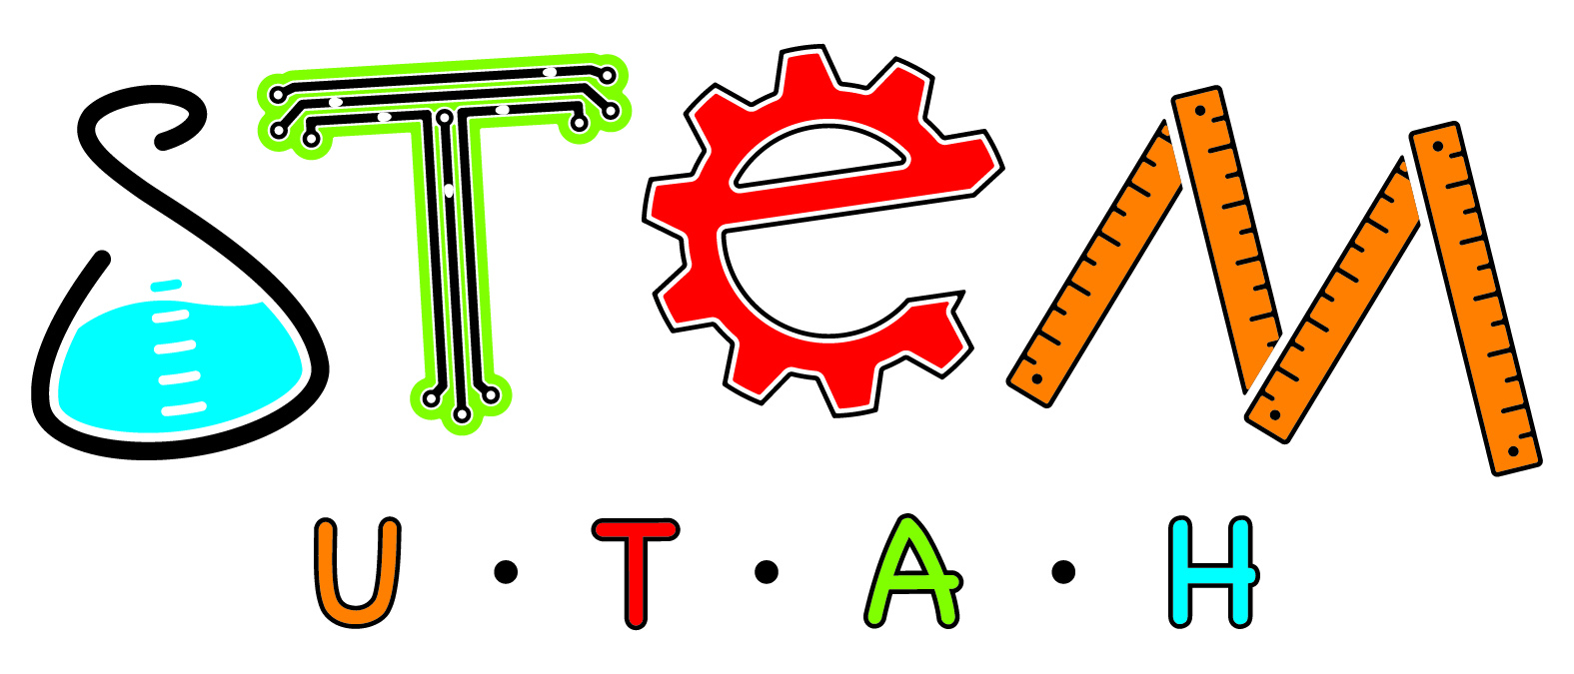

WHEN: Quarters 1 and 2

WHAT: **Task**: You are to develop an in-depth, inquiry-based visual presentation about a topic from the list below that is of interest to you to share with your class:

* + Epi-Genetics
  + Design a LEED Home
  + Hedgehog Particles and Environmentally Friendly Paints
  + Is the Black Death Dead?
  + The 6th Extinction – Acidifying of the Oceans
  + STEM Cell Research
  + DNA and Fingerprinting: Do you inherit your fingerprint
* What determines “handed-ness” – left, right, and mixed-handed people
* Diet and Memory – Is there connection?
* Facial Bone Structure and how people see you.

STEPS:

* Select and Narrow Topic
* Plan timeline and describe steps for completion
* Conference with your science teacher to discuss topic, method of presentation, and timeline
* Prepare visual component – digital or physical (model)
* Practice or prepare presentation – live or digital (using avatar or other)
* Discuss and know class presentation date