|  |  |  |  |  |
| --- | --- | --- | --- | --- |
|  |  | |  | | --- | | Wednesday morning workouts | | October 2017 | |
|  |  |  |
|  |  |  |

This page was created for the use of our community. We value the importance of pushing oneself past their comfort level in order to see the results we want. The workouts below can be completed while keeping a personal goal in mind.

Outside Workouts

**Beginner**

Week 1: Mile Cardio Walk

Week 2: 2 Mile Cardio Walk

Week 3: 1 Mile Run

Week 4: 1.5 Mile Run

Week 5: 2 Mile Run

**Intermediate**

Week 1: 1 mile run, 10 burpees after each lap.

Week 2: 1 mile run, 5 burpees at every turn.

Week 3: 2mile run

Week 4: 2 mile run, 10 burpees after each lap.

Week 5: 2.5 mile run, 5 push-ups after every lap.

**Advanced**

Week 1: Run 1 Lap, 40 air squats, 30 burpees, 20 pushups, 10, walking planks (Elbows to hands) (AMRAP) As many rounds as possible in 10 minutes.

Week 2: Run 1 Lap, 40 air squats, 30 burpees, 20 pushups, 10, walking planks (Elbows to hands) (AMRAP) As many rounds as possible in 10 minutes.

Week 3: Run 1 Lap, 40 air squats, 30 burpees, 20 pushups, 10, walking planks (Elbows to hands) (AMRAP) As many rounds as possible in 15 minutes.

Week 4: AMRAP 20 Minutes

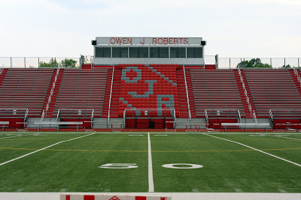

# Welcome to the Workouts

by Ryan Ayres

Things to Remember

Workouts can always be modified to accommodate all skill levels. Exercises can always be subbed in or out of any workout.

