**Strawberry Shortcakes**

8 Servings Prep/Total Time: 30 min.

[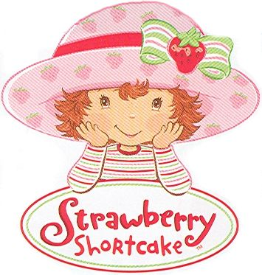](http://www.google.com/url?sa=i&rct=j&q=&esrc=s&source=images&cd=&cad=rja&uact=8&docid=MXPH5fFsxqjAUM&tbnid=Qia6J3aG2yVUoM:&ved=0CAUQjRw&url=http://logos.wikia.com/wiki/Strawberry_Shortcake&ei=n9DKU6yDBcKHyAScyYK4BQ&bvm=bv.71198958,d.aWw&psig=AFQjCNFgzwcAfOolGMrUWV5SzXuA7Vu8ng&ust=1405886997202748)**Ingredients:**

2 cups all-purpose flour

3 tablespoons sugar, divided

1 tablespoon baking powder

1/2 teaspoon salt

1/4 cup cold butter

1 cup milk

2 pints strawberries, sliced

1 tablespoon orange juice

1-1/2 cups whipped cream (1 ½ cups heavy cream + 1 Tbsp. sugar- beat until light and fluffy)

**Directions:**

1. In a large bowl, combine flour, 2 tablespoons sugar, baking powder and salt. Cut in butter until mixture resembles coarse crumbs. Gradually stir in milk until a soft dough forms.
2. Drop the dough by heaping tablespoonfuls into eight mounds on a lightly greased baking sheet. Bake at 425° for 12-15 minutes or until lightly browned. Cool on a wire rack.
3. Meanwhile, place strawberries, orange juice and remaining sugar in a bowl; toss gently. Split shortcakes in half horizontally. Place bottom halves on serving plates; top with whipped cream (see recipe) and strawberries. Replace shortcake tops.