**Teacher/ Student Contract- OJRHS**

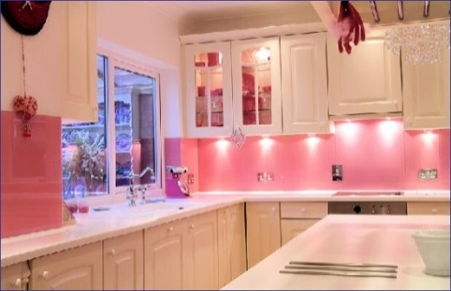The purpose of interior design is to create a functional and beautiful living environment. Home is a place you go to be happy--to get away from the hustle and bustle of the outside world. A home needs to be functional, which means that it is useful and has a purpose. For example, your kitchen is used to store food, cook, and clean up. Your home should also be beautiful--a place where you can relax, be comfortable, and feel at peace. In this course, we will be discussing many topics that revolve around basic home décor and design.

**Course Content**

Unit 1: Elements of Design

* Color
* Line
* Shape
* Space
* Texture

Unit 2: Principles of Design

* Emphasis
* Proportion
* Rhythm
* Scale
* Harmony
* Balance

Unit 3: Textiles and Room Treatments

* Fabrics
* Patterns
* Walls and Ceilings
* Floorings
* Windows and Lighting

Unit 4: Furniture Styles and Layouts

* Types of Furniture

Unit 4: Architecture Styles and Exteriors

* Windows, Floors, Door, Roofs
* Architect Research Project
* Room Design Final Project
* Buying/Renting a Home

Unit 5: Sustainable Design and Interior Trends

* How does technology affect the improvement of exterior design?

As a ***student*** in my class, it is your duty to:

1. Bring a POSITIVE and eager attitude to class every day.
2. Arrive to class on time and remain **seated** until the bell rings. (Lateness will be recorded.)
3. Be ready and PREPARED to learn. Please bring a pencil or writing instrument to class EVERYDAY. ALWAYS put your name on all assignments.
4. Be respectful and courteous to fellow classmates and their possessions.
5. Make up all projects/assignments within a timely basis when absent.
6. NO CELL PHONES unless approved by ME! I have the right to confiscate your phone at any time (and it will not be given back until the end of the class period.)
7. Lastly, remember that you are in a learning environment. Please be careful with all equipment, including the infant simulators. Fooling around and disrespectful behavior WILL NOT BE tolerated and will result in the following:
8. First offense- Verbal warning
9. Second offense- Second verbal warning/parent contact
10. Third offense- detention

Grades:

1. Points will be earned through:

* In-class assignments (20%)
* Projects (50%)
* Quizzes (10%)
* Participation (10%)
* Homework (10%)

1. All points missed due to absence must be made up within 2 weeks or a zero will be given. Late work will be accepted, however points will be deducted from grade each day assignment is late.

After reading the student/teacher contract, please sign and return the following by: _________________________________

Name (printed): ______________________________________________

Student Signature: ____________________________________________

Parent Signature: _____________________________________________

After reading the student/teacher contract, please sign and return the following by: _________________________________

Name (printed): ______________________________________________

Student Signature: ____________________________________________

Parent Signature: _____________________________________________

After reading the student/teacher contract, please sign and return the following by: _________________________________

Name (printed): ______________________________________________

Student Signature: ____________________________________________

Parent Signature: _____________________________________________

After reading the student/teacher contract, please sign and return the following by: _________________________________

Name (printed): ______________________________________________

Student Signature: ____________________________________________

Parent Signature: _____________________________________________