**Greek Yogurt Chocolate Chip Scones**

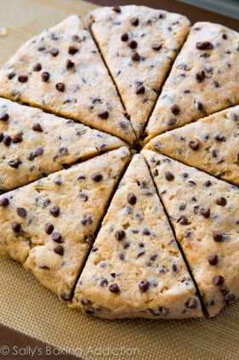Ingredients:

¾ cup whole wheat flour

¾ cup all-purpose flour

1 ½ tsp. baking powder

½ tsp. salt

2 tbsp. unsalted butter, very cold and cubed

½ cup plain nonfat Greek yogurt

3 tbsp. maple syrup (or honey/agave)

2 tbsp. + 2 tsp. nonfat milk

1 tsp. vanilla extract

1/4 cup miniature chocolate chips

Directions:

1. Preheat the oven to 425°F, and line a baking sheet with a silicone baking mat or parchment paper.

2. In a medium bowl, whisk together the flour, baking powder, and salt. In the same bowl, cut in the butter with a pastry blender until the mixture resembles fine crumbs. It will be thick!

3. Stir in the Greek yogurt, maple syrup, 2 tablespoons of milk, and vanilla. Fold in chocolate chips.

4. Shape the dough into a ¾” tall circle on the prepared baking sheet, and brush with the remaining milk.

5. Slice the circle into 8 triangular segments with a sharp knife very carefully- not to cut into the cookie sheet.

6. Bake at 425°F for 17­20 minutes, or until the tops are lightly golden. Cool on the pan for 5 minutes before transferring to a wire rack.