Soft German Pretzels

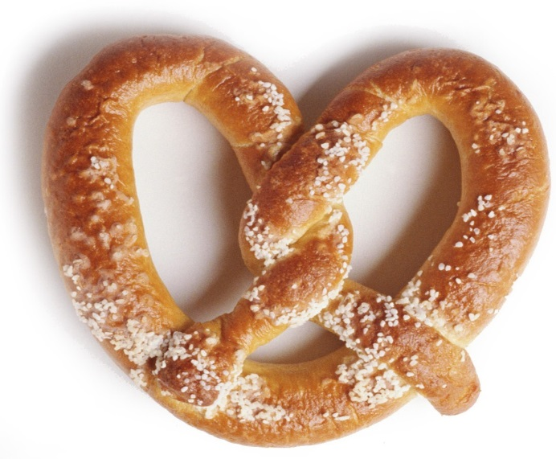Ingredients

1 package dry yeast

¼ cup warm water

2 teaspoons brown sugar

2 tablespoons butter melted

5 ½ cups bread flour

1 tablespoon kosher salt

1 2/3 cup water

Day 2

Pretzel salt

1 egg with a splash of water (mix this in a small glass bowl)

¾ cup baking soda

8 cups water

Instructions

Day 1

1. Dissolve the yeast in 1/4 cup warm water until it bubbles.

2. In a mixing bowl, mix together the brown sugar, butter, yeast, 1 2/3 cups warm water and half the flour. Add the kosher salt and remaining flour and stir just until mixture comes together in a shaggy mass.

3. Turn out onto counter and knead for 8 to 10 minutes, until smooth and supple. Cut into 12 pieces and let rest 5 minutes.

4. Roll out each piece into a rope about 22 inches long. (For traditional shape, the ends should be thin and the center fat). From each long piece, shape into a pretzel (see video). Transfer shaped pretzels to an un­greased baking sheet.

5. Let rest at room temperature for 30 minutes, then refrigerate at least one hour or overnight.

Day 2:

6. Heat oven to 425 degrees.

7. In a large, deep pot, stir the baking soda into 2 quarts of water and bring to a simmer over high heat. Reduce the heat to moderate. Using a slotted spoon, carefully transfer pretzels to the simmering water 30 seconds, turning once. Transfer the pretzels to a cutting board or rack to drain, then return them to the cookie sheets, spacing them evenly.

8. Brush with egg wash. Sprinkle pretzels with salt. Bake about 15 minutes or until deep brown. Remove to a rack and serve warm.