Basic Butter Dough for Cookie Press Cookies (Spritz Cookies)

[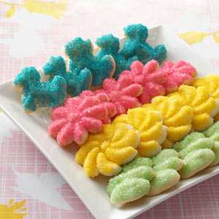](http://www.google.com/url?sa=i&rct=j&q=&esrc=s&frm=1&source=images&cd=&cad=rja&uact=8&ved=0CAcQjRw&url=http://www.tasteofhome.com/recipes/spritz-cookies&ei=3bImVfKmCe7HsQSz3oKAAg&bvm=bv.90491159,d.cWc&psig=AFQjCNG7ygOBmEeg7im4VSuv6P72Qfn-1A&ust=1428685896875963)Makes 2-3 dozen cookies

Ingredients

* 1 1/2 cups (3 sticks) unsalted butter
* 1 cup sugar
* 2 large egg yolks
* 3 3/4 cups sifted all-purpose flour
* 1/4 teaspoon salt
* 1 tablespoon pure vanilla extract
* Colored sanding sugar

Directions

1. Heat oven to 350 degrees. In a large bowl, cream butter and sugar until light and fluffy. Add egg yolks, flour, salt, and vanilla. Mix thoroughly.
2. Fill a cookie press with the dough, and turn out cookies 1 to 2 inches apart onto an unbuttered baking sheet. Sprinkle cookies with colored sanding sugars.
3. Bake until the cookies are lightly browned, 7 to 10 minutes. To ensure even baking, rotate sheet halfway through the baking process. Transfer to a wire rack, and let cool.

How to Fill a Cookie Press

Fill a cookie press with the dough by using a ____________.

Then, put the lid on top and screw on so ___________________.

After, slowly turn out cookies 1 to 2 inches apart onto an ________________ baking sheet.

Sprinkle cookies with colored sanding sugars. To ensure even baking, ___________ sheet halfway through the baking process (optional).

For molded cookies:

Try:

* 1. Roll the cookie dough into a ball and use a fork to mold the shape of the cookie (decorative touch)
  2. Use a brand new or clean rubber or plastic stamp to create a decorative look.
  3. Use a cookie mold or pan that would mold the cookie such as a sea shell or flower.