Name: __________________________

Mrs. Bickell

LA Period _______

Date: _____________________

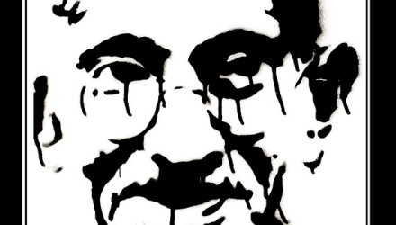

**Research-Based Poetry**

**WHAT are we doing?**

Students will **utilize electronic research tools**, demonstrate **application of a variety of poetry tools**, and **write and digitally present a poem** about a significant person from a subject studied during the seventh grade year.

**WHY this assignment?**

A culminating, multi-disciplinary activity, the research poem challenges students to utilize non-fiction information to develop a creative product. On the journey to create this poem, students will have the opportunity to evaluate online resources, learn how to use Noodle Tools, use figurative language and sound devices, and more deeply explore critical individuals from the 7th grade curricula.

**HOW will we execute this task**?

Step One**:** Choose a **person** to research from the list provided. (If you would like to research someone else OR try one of the advanced options, please have this approved by your teacher.)

Step Two:Engage in the three*library* sessions regarding evaluating online resources and creating electronic note sheets with Mrs. Potter. (May 6,7,8)

Step Three:Decide what **topics** you need to research in order to create your poem.

Consider the following **Sub**-**TOPICS**:

* FAMILY: Who are the members of his/her **family**? What was his/her *upbringing* like? Early years?
* HISTORY / PAST: What happened in his/her past? Family lines, bloodlines?
* SETTING: Where did he/she **live** and more importantly what was the place like?
* TRAITS: How would you **describe this person’s personality**?
* SIGNIFICANCE: What makes this person historically **important or memorable**?
* LIFE CHOICES/CONSEQUENCES: What were some **significant choices** he/she made? What were some **significant moments in their life**?
* DEATH /BURIAL: *How* did he/she **perish**? Was the passage marked by a burial or ritual? Where were the remains buried or kept? If still living – what is life like today for him/her?

Step Four:Research and track your findings through the use of Noodle Tools. You will need **minimum** of **6 labeled notecards & a *minimum* of 3 sources** for your Works Cited page. These will be checked periodically throughout the project.

Step Five: Write your **poem**. Use the example provided by Mrs. Bickell if you are struggling to create a format for your own poem.

This poem MUST include:

* **6 stanzas with a minimum of 4 lines per stanza**- inspired by the tone and work “I am the Mummy Heb- Nefert.”
* **4 examples** of figurative language: simile, metaphor, symbolism, hyperbole and/or personification
* **2 sound devices**: repetition, rhyme, magic 3, alliteration, assonance and/or onomatopoeia
* **Multiple uses of researched material to make the poem authentic and educational**

Step Six: Create a **digital final product** of your poem and **present** this to your class. Be creative! Consider the following options: **Website, Glogster, PowerPoint, Prezi, Google Doc, Movie Maker, iMovie or any other idea as long as it is approved by your teacher.**

Step Seven: Practice reading your poem aloud. Be familiar with the entire poem so you can read it confidently. Bring in **ONE ITEM** for each of the six stanzas that you will share with your listening audience to provide a visual an focus and teach them about your research person or idea.

Social Studies:



Topic Options



* Mohandas Gandhi
* Ghenghis Khan
* Tenzing Norgay
* Octavia Minor - female
* Hatshepsut - female
* Cleopatra - female
* Khufu
* Nefertiti – female
* Sir Edmund Hillary
* Julius Ceasar
* Augustus
* Tuthankhamen (King Tut)
* Alexander the Great
* Mumtaz Mahal - female
* Mohammad (also spelled Mohammed) – Founder of Islam
* Mother Theresa - female
* Saladin – compassionate Muslim conqueror
* Enheduanna – female, first known author
* P’u Yi – last Chinese emperor
* 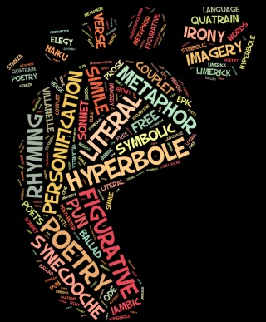Shi Huangdi – first emperor

Science:

* Gregor Mendel- genetics
* Barbara McClintock
* Robert Hooke- cells
* Sally Ride
* Charles Darwin- evolution
* Rachel Carson
* Ava Lovelace
* Rosalind Franklin
* James Watson and Francis Crick
* Marie Curie

Exploring Technology:

* Steve Jobs

Foreign Language:

* Frida Kahlo
* Christopher Columbus

Music:

* Johann Sebastian Bach
* Amadeus Mozart
* Ludwig Von Beethoven
* Louis Armstrong
* Elvis Presley
* John Lennon – of the Beatles
* Michael Jackson

Language Arts:

* William Shakespeare
* Maya Angelou
* Lewis Carroll
* Shel Silverstein

**Advanced** Topic Options

IMPORTANT NOTE

** Choosing one of these topics WILL require you to create or adjust your own outline topics, think very creatively, be more independent in developing stanzas, and make other adjustments to the assignment that students with **traditional** topics might not have to consider. You take on the *responsibility* that comes with an advanced topic in choosing one of these options. And you will think of any inanimate (non-living) options as a person as you write.

* Pantheon
* Colosseum
* The Roman Forum – Senate steps
* The Great Pyramid
* The Sphinx
* 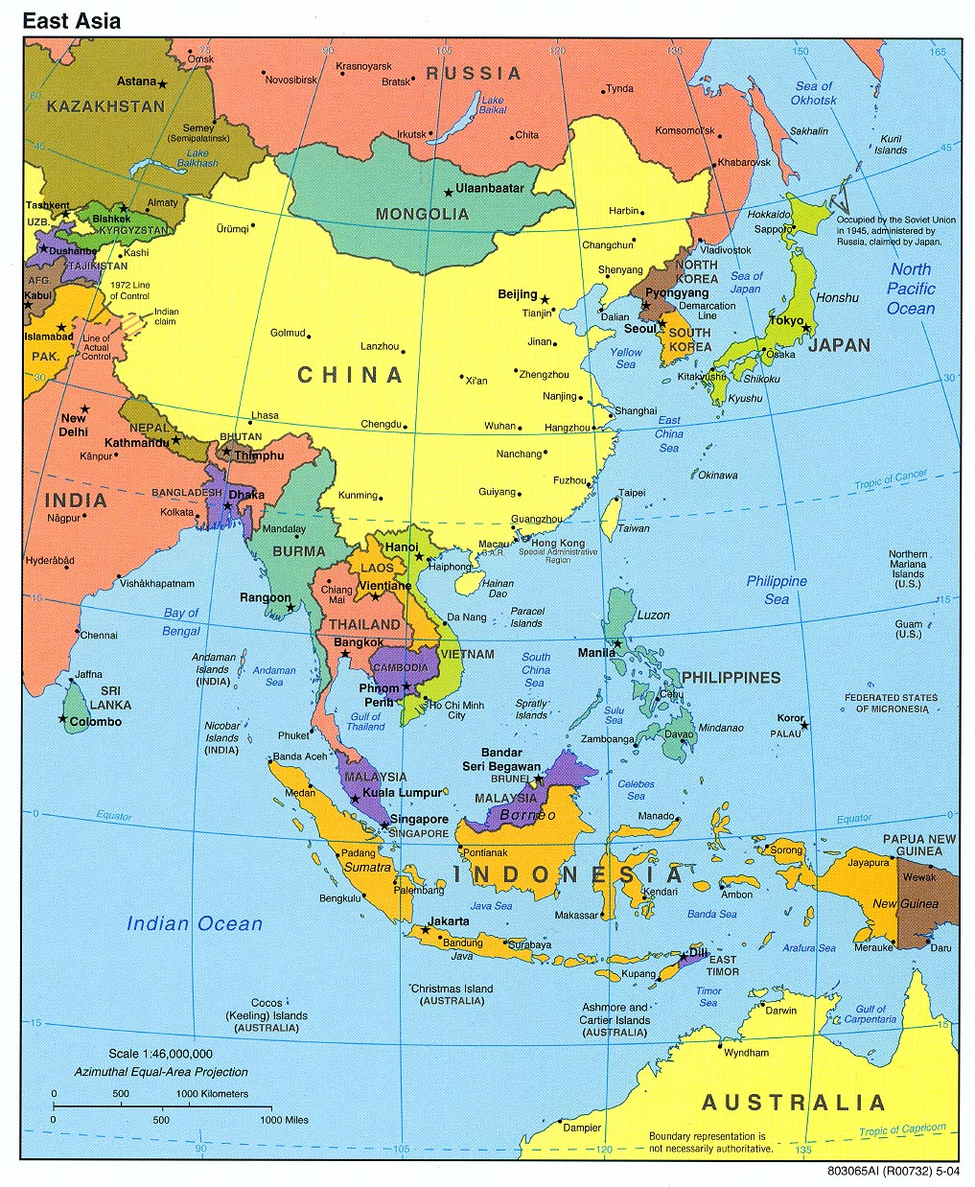The Rosetta Stone
* Taj Mahal
* Ganges River
* Mount Everest
* The Fertile Crescent
* Forbidden City
* The Great Wall of China
* Terra Cotta Soldiers
* Jerusalem
* A Spartan Woman
* An Untouchable
* Greece
* Rome
* India
* The Middle East
* China
* Egypt

Research Poem Format

**Keep in mind you MUST have a **minimum** of four lines per stanza, and a minimum of 6 stanzas total, with a cleverly crafted title. The required stanzas should start with these statements.

**Title (Focused and Interesting)**

**Stanza One: FAMILY or HISTORICAL PAST**

**I am**

**Stanza Two: SETTING**

**I live**

**Stanza Three: TRAITS / SIGNIFICANCE**

**I accomplish**

**Stanza Four: LIFE CHOICES / CONSEQUENCES**

**I believe, I decide, I choose**

**Stanza Five: DEATH / BURIAL or LIFE TODAY**

**I am**

**Stanza Six: REPEAT Stanza 1 (either exactly or mostly repeated)**

Research Poem / Assessment Information

Presentation CHECKLIST

|  |  |  |  |
| --- | --- | --- | --- |
| **Format/Following Directions:** | **10 per** | **FILL in Requirements:** |  |
| **6 stanzas, 4 lines each min** |  | **What 6 ITEMS will you use as a visual?** |  |
| **Each stanza begins with “I” statement** |  | **1** |  |
| **Researched material evident throughout.** |  | **2** |  |
| **POETIC Material woven *throughout*.** |  | **3** |  |
| **Is skillfully presented digitally – read with fluency and inflection** |  | **4** |  |
| **Sound devices were clearly highlighted, colored, etc. and were evident in the poem.** |  | **5** |  |
| **Figurative Language was highlighted, colored, etc. to be evident in the poem** |  | **6** |  |
| 10 Points PER category… |  |  |  |

Total ______________ / 70

Example Poem:

**_Scoundrel of Da Sea_**

OPENING STANZAS (1/2): Family/History

I am the Admiral of Arabian Seas.

The punishing Pirate of Persia

Sixteenth Century Seeker of spices and teas

Son of Portugal, trader to India.

I am the descendant of the noble class.

Married a high-born, heiress lass.

Isabel was my precious wife

Who was my partner all my life.

Six strapping sons she bore for me

Though I spent most of our lives married to the sea.

STANZA 2 Requirement: Setting

I live for the ruffle of bluffing sails,

Born in Sines but longed to India see.

Salty monsoons blew us toward trading trails

There my merchant fleets of accomplishment be.

Stanza 3 Requirement: Traits/Historical Significance

I accomplished a treacherous *task*, as King John II, *asked*.

As the Cape of Good Hope I did seek,

Met the Sultan of Mozambique.

Wrestled a cruel, unforgiving sea.

Now a famous explorer I be.

Stanza 4 Requirement: Life Choices/Consequences

I chose a near 200 men crew.

2 years on winged sails we flew.

300 days on the briny blue seas

Making enemies while trading teas

Only 54 Lisbon’s sons returned

24,000 nautical miles we burned.

One of the dead was my kin,

Case of scurvy did him in.

Stanza 6 Requirement: Repeated first stanza

I am the Admiral of Arabian Seas.

The punishing Pirate of Persia

Sixteenth Century Seeker doing *whatever* I please…

Son of Portugal, villain to India.