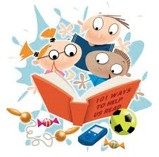

**Reading Strategies Checklist**

**Always wait until the student reads to the end of the sentence before prompting with the then statement.**

IF THEN

|  |  |
| --- | --- |
| If student misreads a word | Say “Check the picture. Does it look right and make sense? Reread and think about the story”. |
| If student misreads the end or middle of a word | Say “Check the end (or middle) of the word. What would look right and make sense there”? |
| If student comes to an unknown word, wait 3 seconds | Say one of these depending on the type of word:  “Cover the ending. Is there a part you know”?  “Do you know another word that looks like this one”?  “Chunk the word and think what would make sense”. |
| If student is not attending to punctuation and/or not reading with expression. | Say “Try reading that like the character would say it”. |