**French Toast Sticks**

* 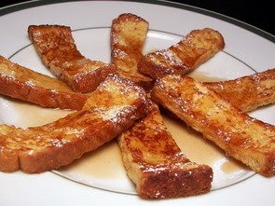**Prep Time:** 20 mins
* **Total Time:** 30 mins
* **Yield:** 16 strips

**Ingredients:**

* + 1 egg
  + 2 Tbsp. milk
  + 1 tablespoons maple or regular syrup
  + 1/2 teaspoon brown sugar
  + 1/8 teaspoon ground cinnamon
  + 4 slices white bread, each cut into 4 strips
  + 1 1/2 tablespoons butter

**Directions:**

1. In a bowl, beat together the eggs, sugar, milk, maple syrup, brown sugar, cinnamon, and nutmeg with a fork or whisk until well blended.
2. Dip each bread strip into the egg mixture, coating completely, but not so that it is soggy.
3. In a large skillet, melt 1 1/2 tablespoons butter over medium heat.
4. Cook the bread strips a few at a time for 2 to 3 minutes per side, or until golden, adding more butter as needed. Serve with syrup and butter if desired.

Basic Cheesy Omelets

**Prep Time: 15 Minutes**

**Cook Time: 30 Minutes**

**Servings: 2 omelets**

**Ingredients:**

6 eggs, lightly beaten

½ cup shredded Cheddar cheese

2 Tbsp. milk or heavy cream (optional)

Toppings:

Green Peppers, onions, and tomatoes

**Directions:**

* + 1. Coat the bottom of a large, lightly greased skillet with three eggs, and cook over medium heat until firm.
    2. Top with your choice of vegetables and Cheddar cheese. Fold egg in half over fillings, and serve warm. Repeat with remaining ingredients.