Crispy Microwave Potato Chips

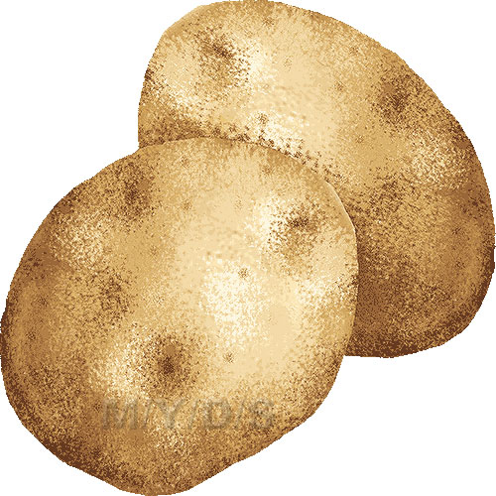I prefer to leave the potato skins on for more nutrition and for looks, but feel free to peel them if that’s your thing.

Ingredients

*3 Russet (baking) potatoes or sweet potatoes

*salt, to taste

Ranch Dip (Or French Onion)

*1/2 cup sour cream

*1-2 Tbsp. Hidden Valley Ranch dip mix

*1 Tbsp. chives

Instructions

1. Wash and slice potatoes as thinly as possible.
2. Submerge slices in bowl of cold water as you go. You can leave them in the water for 1 minute or so, if desired, to remove some of the starch.
3. Once you’re ready to microwave, rinse the potatoes until the water runs clear; drain.
4. Pat the potato slices dry between two clean kitchen towels. Place slices, in a single layer, on a paper towel lined microwave-safe plate (you will need to do this in batches). Sprinkle with salt.
5. Microwave on high for ABOUT 3 minutes (You may need to check before the 3 minutes are up so they do not burn). Flip the potatoes **(careful they’re hot!).** Make sure you place enough potatoes on the plate so they do not BURN. Meanwhile, make dip by mixing sour cream with dip mix and chives.
6. Cook for an additional 3 minutes. Remove any chips that are crisp. Continue cooking, one minute at a time, until all chips are golden and crisp. (They should look shriveled and somewhat brown).
7. Repeat with remaining potato slices. Serve immediately or allow to cool and store in an airtight container for several days. Serve with dip.