Waffle Cone Fruit Cornucopia

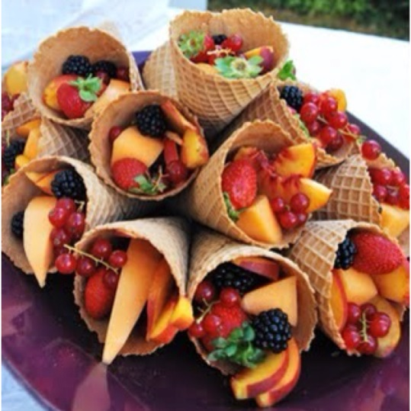

Ingredients

|  |  |
| --- | --- |
|  | Assorted fruit, peeled, sliced, and otherwise prepared |
|  | Waffle Cones |

Directions

Assemble to please the eye.