Potato Pampushki With Cheese Filling

Serves: 8 Pampushki

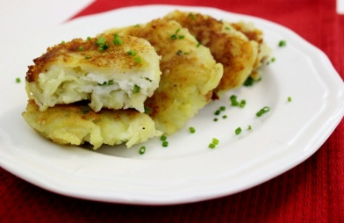Ingredients

1 1/4 cups mashed potatoes

3/4 lbs. of potatoes, about 2 medium­sized (preferably Yukon Gold)

Salt, pepper

¼ cup farmer's cheese or Ricotta

2 Tbsp. parmesan cheese, grated

1 Tbsp. dried chives

2­4 Tablespoons heavy cream

Oil, for pan frying

Instructions

1. Peel potatoes and grate on a box grater. Squeeze out all moisture by placing the potatoes in a cheesecloth or kitchen towel and squeeze out all excess moisture.

2. Combine the grated potatoes with the mashed potatoes. Season with 1/2 teaspoon of salt and ¼ teaspoon of pepper. You can also add caramelized onions to the potato mixture for added flavor. Set aside.

3. In another bowl, combine the rest of the ingredients for the cheese filling.

4. Take about a ¼ cup of potato mixture and form into a patty. Place about a 1½ teaspoon of the cheese filling and place into the center of the patty. Fold the potato mixture over the cheese filling, shaping it into an oval shape.

5. In a nonstick skillet, heat about 2 Tablespoons of oil and add the pampushki. Cook the potato pampushki on medium heat, about 5­7 minutes per side, until golden brown.

6. Drain the potato pampushki on paper towels.