Easy No-bake Chocolate Éclair Cake

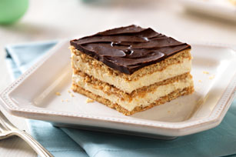Yield: Makes one 9" x 13" cake

Ingredients:

1 (16 ounce) package graham crackers

2 (3.5 ounce) packages instant vanilla pudding mix

3 cups milk

1 (8 ounce) package frozen whipped topping, thawed

Prepared chocolate frosting (see below)

Creamy Chocolate Frosting

\*1/3 c. cocoa powder \*1 c. sugar \*1/4 c. milk \*1 stick (1/2 c.) butter \*1 tsp. vanilla

Instructions for Icing

1 . Bring cocoa, milk, and sugar to a full rolling boil; boil about 1 minute, stirring very frequently. Remove from heat and cool one minute. Add butter and vanilla; stir until butter is melted. Pour chocolate topping over the top layer of graham crackers.

Cake Directions:

1. Line the bottom of a 9x13 inch baking pan with graham crackers. In a large bowl, combine the milk and vanilla pudding by whisking with a whisk or in a KitchenAid mixer with a whisk attachment. Fold in the whipped topping.
2. Spread a layer of the pudding mixture over the graham crackers. Alternate the graham cracker and pudding layers up to the top of the pan. (Should be 3 graham cracker layers and 2 cream layers).
3. Once prepared, pour frosting over the top of the cake. Refrigerate for at least 12 hours before serving.