**PF Chang’s Chicken Lettuce Wraps**

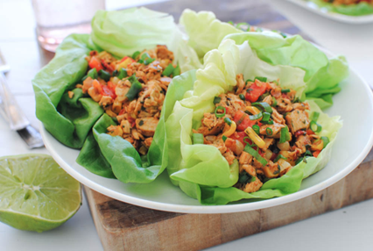1 Tbsp. sesame oil, divided  
1/2 lb. ground chicken  
1 garlic clove, minced  
3 basil leaves, fine chiffonade

1 Tbsp. teriyaki sauce  
1/2 Tbsp. soy sauce  
1/2 tsp. vinegar  
1/2 tsp. ground ginger  
1/2 tsp. cornstarch  
1/2 Tbsp. Sriracha sauce or chili garlic sauce (to taste, optional)

1/2 head bibb or romaine lettuce, separated into leaves or “bowls”  
1 small green onion, sliced

Directions:

1. In a medium wok or skillet over medium heat, add sesame oil to the skillet and bring to medium-high heat. Add the chicken and cook until done, about 4-5 minutes, crumbling the meat as it cooks. Drain fat, if needed.
2. Add the minced garlic, stir for 30 seconds. Sprinkle in the basil leaves; stir to combine.
3. Meanwhile, in a small mason jar or mixing bowl, combine the  teriyaki sauce, soy sauce, rice wine vinegar, ground ginger, cornstarch, and sriracha; shake or whisk to combine.
4. Pour sauce over the chicken mixture and stir to coat evenly; cook until heated through and slightly thickened, about 1 minute.
5. Spoon into the leaves of butter lettuce (or scoop over bowls of rice). Top with sliced green onions.