Cupcake and Icing Tutorial

Makes: 12 cupcakes and 2 circular cake pans

Vanilla Sour Cream Pound Cake

3 level cups sugar

2 sticks butter (room temp.)

6 eggs

3 level cups flour

1/2 tsp. salt

1/4 tsp. baking soda

2 tsp. vanilla extract (pure is best)

8 oz. sour cream

Directions:

1. Preheat oven to 350 degrees. Cream butter and sugar together.
2. Beat in eggs one or two at a time.
3. Alternate adding in flour and sour cream, then add flavorings.
4. Bake at 350 degrees for 20-25 minutes or until toothpick comes out clean.

Vanilla Buttercream Frosting

3 cups confectioners' sugar

1 cup butter

1 teaspoon vanilla extract

1 to 2 tablespoons whipping cream or milk

1. In a standing mixer fitted with a whisk, mix together sugar and butter. Mix on low speed until well blended and then increase speed to medium and beat for another 3 minutes.
2. Add vanilla and cream and continue to beat on medium speed for 1 minute more, adding more cream if needed for spreading consistency.

Décor Techniques

[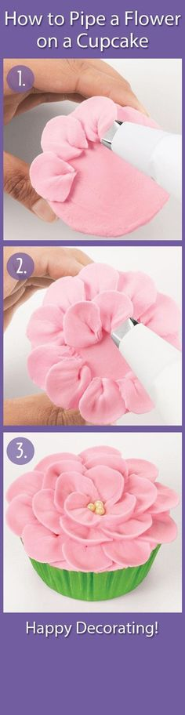](https://www.google.com/url?sa=i&rct=j&q=&esrc=s&frm=1&source=images&cd=&cad=rja&uact=8&ved=0CAcQjRw&url=https://www.pinterest.com/knitn/cake-decorating-tips-and-techniques/&ei=sp4vVfTOO5aQsQSJvoGwBA&bvm=bv.91071109,d.cWc&psig=AFQjCNGy-KA9b6ZrSmmwhnwkyOM5ii-1AA&ust=1429270567609965)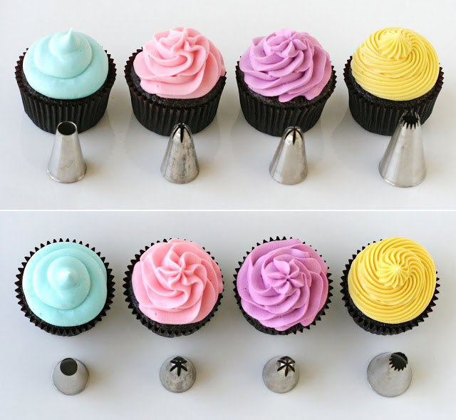 How to Pipe a Rose:

Tips and Shapes:

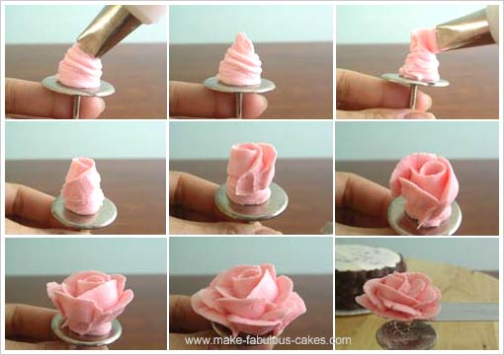More Décor Techniques:

http://www.stilettosandlegos.com/makes-life-easier/august-23rd-2012/