Black Bean & Corn Quesadillas

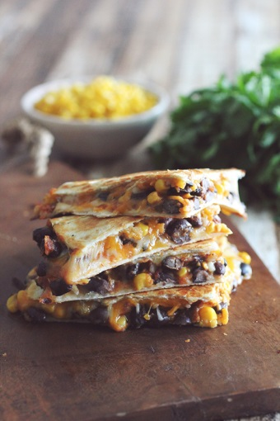Cook Time: 10-15 minutes.

Ingredients:

1/2 (15 oz.) can Black beans, rinsed and drained

1/2 cup Corn

1/4 cup Salsa

1 tsp. Taco seasoning

2 Tbsp. Fresh cilantro, chopped (or green onions)

1/2 cup Shredded cheese of choice

4 flour tortillas

Sour cream

Directions:

1. In a medium bowl, mix together beans, corn, salsa, taco seasoning and cilantro (filling).
2. Preheat a large skillet over medium low heat, sprayed with cooking spray. Place one tortilla in the skillet, and scoop 1/2 cup of the filling onto the tortilla in the pan.
3. Sprinkle cheese over the bean mixture, and place second tortilla on top of the cheese. Press down on top tortilla lightly with the back of your spatula, so you can meld the tortillas together as the cheese melts. When the bottom tortilla begins to brown, flip the quesadilla over until both tortillas are lightly browned and crispy and the cheesy filling has melted.
4. Do again with second quesadilla. Cut into wedges if desired and enjoy! Top with sour cream if desired.