**Teacher/ Student Contract- OJRHS**

In this course, students will continue to put knowledge about children into action in working with preschool age children. A laboratory preschool is conducted within the second month of the course. Students will further build on their experiences from Preschool Lab 1. The knowledge and skills required by professionals working with children are key components. Students will be expected to perform at a “college-level” by demonstrating a rigorous effort and establishing a meaningful repertoire with children. This course is recommended for students who are strongly considering a career in education or a career field involving children.

**Course Content**

Unit 1: The 21st Century Educator- (Week 1/2)

* 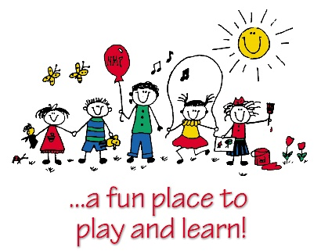Differentiating Instruction: What type of learner are you?
* Meeting the Needs of Unique Learners
* DAP Guidelines/Preschool Standards/Lesson Planning Review

Unit 2: Professionalism and Effective Communication (2 weeks before preschool opens)

* How do you communicate effectively with parents?
* What professional duties are you responsible for as a teacher?

Unit 3: Teaching Visual Learners (2 weeks)

Unit 4: Teaching Mathematical/Logic Learners (2 weeks)

Unit 5: Teaching Kinesthetic Learners (2 weeks)

Unit 6: Teaching Auditory and Musical Learners (2 weeks)

Unit 7: Teaching Verbal/Linguistic Learners (1 week)

Unit 8: Teaching Intrapersonal and Interpersonal Learners (2 weeks)

Unit 9: Quality Education- A Multi-sensory Approach and Job Interviewing Skills- (last month of the semester)

* What types of learning curriculums exist for children (play-based)?
* Field Trip (possible) to childcare facility
* Mock Interview and Resume

As a ***student*** in my class, it is your duty to:

1. Bring a POSITIVE and eager attitude to class every day.
2. Arrive to class on time and remain **seated** until the bell rings. (Lateness will be recorded.)
3. Be ready and PREPARED to learn. Please bring a pencil or writing instrument to class EVERYDAY. ALWAYS put your name on all assignments.
4. Be respectful and courteous to fellow classmates and their possessions.
5. Make up all projects/assignments within a timely basis when absent.
6. NO CELL PHONES unless approved by ME! I have the right to confiscate your phone at any time (and it will not be given back until the end of the class period.) **Note, on preschool lab days, participation points will be taken off for cell phone usage.**
7. Be SERIOUS. You will be working with children and parents from the community; therefore, how you portray yourself is very important. Immaturity WILL NOT be tolerated.
8. Lastly, remember that you are in a learning environment. Fooling around and disrespectful behavior WILL NOT BE tolerated and will result in the following:
9. First offense- Verbal warning
10. Second offense- Second verbal warning/parent contact
11. Third offense- detention

Grades:

1. Points will be earned through:

* In-class assignments (20%)
* Participation (20%)
* Projects (30%)
* Performance (20%)
* Homework (10%)

1. All points missed due to absence must be made up within 2 weeks or a zero will be given. Late work will be accepted, however points will be deducted from grade each day assignment is late.

After reading the student/teacher contract, please sign and return the following by: _________________________________

Name (printed): ______________________________________________

Student Signature: ____________________________________________

Parent Signature: _____________________________________________

After reading the student/teacher contract, please sign and return the following by: _________________________________

Name (printed): ______________________________________________

Student Signature: ____________________________________________

Parent Signature: _____________________________________________

After reading the student/teacher contract, please sign and return the following by: _________________________________

Name (printed): ______________________________________________

Student Signature: ____________________________________________

Parent Signature: _____________________________________________

After reading the student/teacher contract, please sign and return the following by: _________________________________

Name (printed): ______________________________________________

Student Signature: ____________________________________________

Parent Signature: _____________________________________________