Banana Oatmeal Muffins (gluten free)

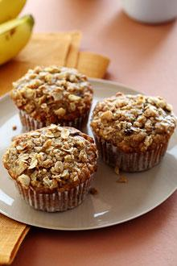1 cup plain Greek yogurt  
2 very ripe (spotted) bananas, mashed   
2 eggs  
2 cups gluten-free oatmeal, ground  
1 1/2 tsp baking powder  
1/2 tsp baking soda  
1/4 tsp cinnamon  
1/8 tsp nutmeg

¼ cup honey or agave nectar or sugar

½ cup mini chocolate chips

Directions:

1. Prepare a muffin pan by spraying with cooking spray. If using liners, spray those as well as these muffins will stick.
2. Grind the oatmeal in batches in a food processor or clean coffee grinder. Pour the oatmeal flour into a medium bowl and stir in baking powder, baking soda, cinnamon, and nutmeg. Set aside.
3. In a small bowl, mix the yogurt, honey, mashed bananas, and eggs together. Pour the banana mixture into the oat flour mixture and stir just until blended. Add chocolate chips.
4. Scoop batter into muffin pan and bake at 400 degrees for 12-15 minutes. (10 minutes if you’re using a mini muffin pan.)

Muffin method questions:

1. The first step of the muffin method is……. __________________________________________________________________________________________________________________________________________________
2. Then, make a __________________ in the center of the dry ingredients.
3. Combine all of the ________________________ ingredients (well beaten/combined) to the __________________ ingredients.
4. Mix the 2 ingredients together until _____________________________. DO NOT __________________________!

The good, the bad, and the ugly (Draw and label the following)

|  |  |  |
| --- | --- | --- |
| High Quality Muffin | Undermixed Muffin | Overmixed Muffin |

The Biscuit Method

1. Combine all ________________ ingredients.
2. Using pastry blender cut in the _____________ into the dry ingredients.
3. Add the _________________ ingredients until a dough forms.
4. Stop here if making drop biscuit. Otherwise, for rolled biscuits, continue to roll dough out onto a flat surface about__________________ times. Cut into biscuits with biscuit cutter.