**Chocolate Banana Brownies (Bar Cookies)**

Serves: 8x8-inch pan of brownies (see note for servings)

[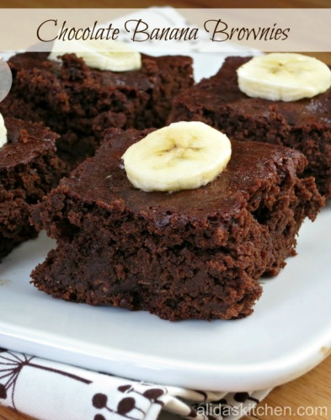](http://www.google.com/url?sa=i&rct=j&q=&esrc=s&frm=1&source=images&cd=&cad=rja&uact=8&ved=0CAcQjRw&url=http%3A%2F%2Falidaskitchen.com%2F2013%2F07%2F11%2Fchocolate-banana-brownies%2F&ei=Da0rVcKjLuzIsATu7YDYAw&bvm=bv.90491159,d.cWc&psig=AFQjCNF2dxKbGI8LmkTpYMJBWEdlBcyUmw&ust=1429012107069705)**Ingredients**

* 1 1/2 cups all-purpose flour
* 1 1/2 cups packed brown sugar1/2 cup unsweetened cocoa powder
* 3/4 teaspoon baking powder
* pinch of salt
* 3/4 cup mashed overripe bananas (about 2 medium) (egg substitute)
* 3 tbsp. almond milk (dairy substitute)
* 3 tbsp. canola or vegetable oil
* 3/4 teaspoon vanilla extract
* 1 cup semi-sweet chocolate chips
* Cooking spray

**Instructions**

1. Preheat oven to 350*F. Spray an 8x8-inch baking pan with cooking spray and set aside.
2. In a large bowl, whisk flour, brown sugar, cocoa, baking powder and salt.
3. In a medium bowl, stir bananas, milk, oil, and vanilla until well-blended.
4. Add banana mixture to flour mixture, gently stirring until just combined. Add chocolate chips, folding gently.
5. Pour batter into prepared baking pan and bake for 18-25 minutes, or until a toothpick inserted in the center comes out clean. (Be careful not to over bake, otherwise the brownie may not be as fudgy). Move pan to a wire rack to cool completely. Cut into squares to serve.